You must have an Intrinio subscription to the Toronto Stock Exchange Prices in order for this program to work properly. You may view the subscription under the appropriate tab in the My Account section of the Intrinio website:
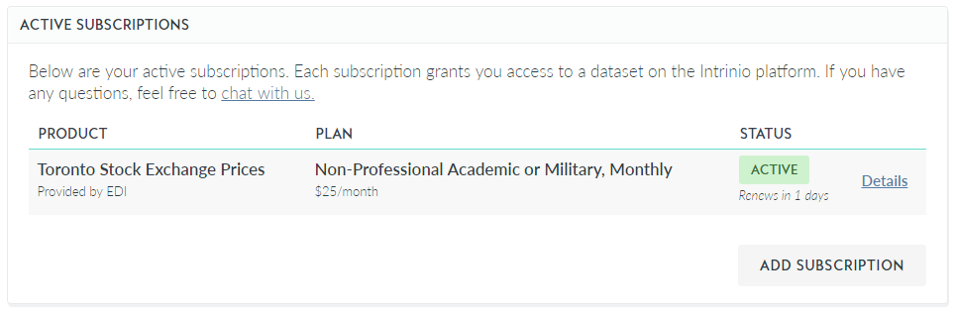
To obtain the API key, username and password, click on the Access Keys tab while in My Account, and click on the clipboard icons to copy them:
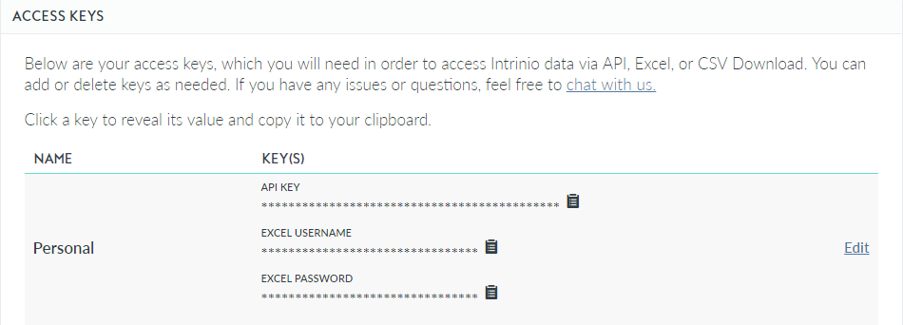
Once copied, put the values in the appropriate string variables inside .com.mtlcollege.quickstocks/util/Credentials.java:
